**ASSIGNMENT 4**

**AIM:-**

Write a PL/SQL code to implement all types of cursor (Implicit, Explicit) and display

employee number, name and salary of 5highest paid employees using

cursor.Employee (employee no, employee name, join_date, designation, salary).

**OBJECTIVE:-**

To implement Implicit and Explicit Cursor.

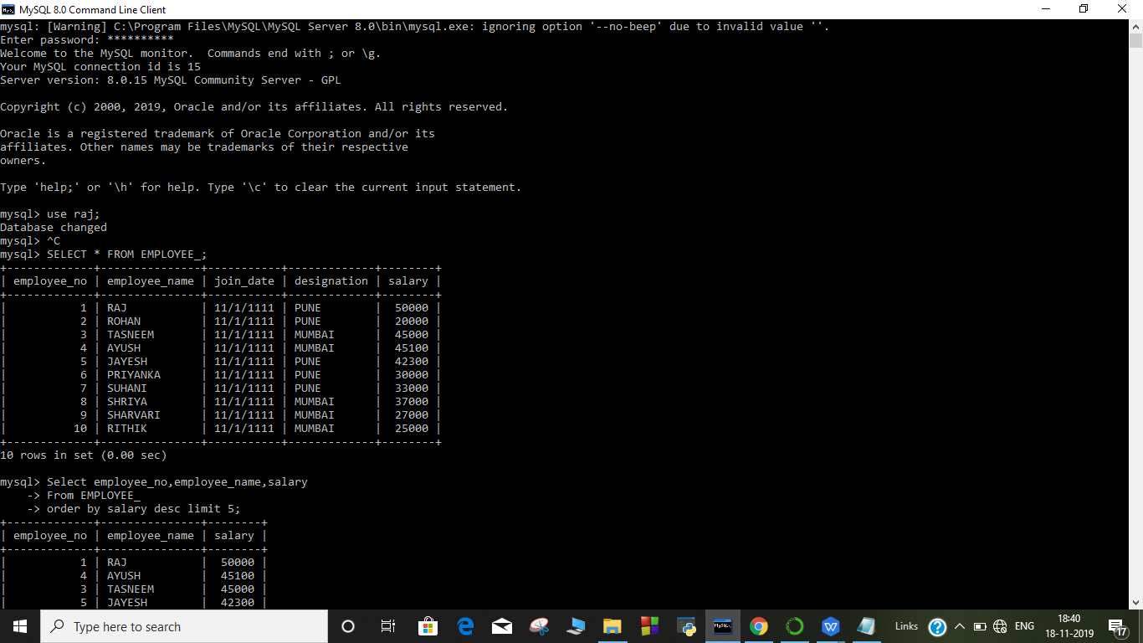

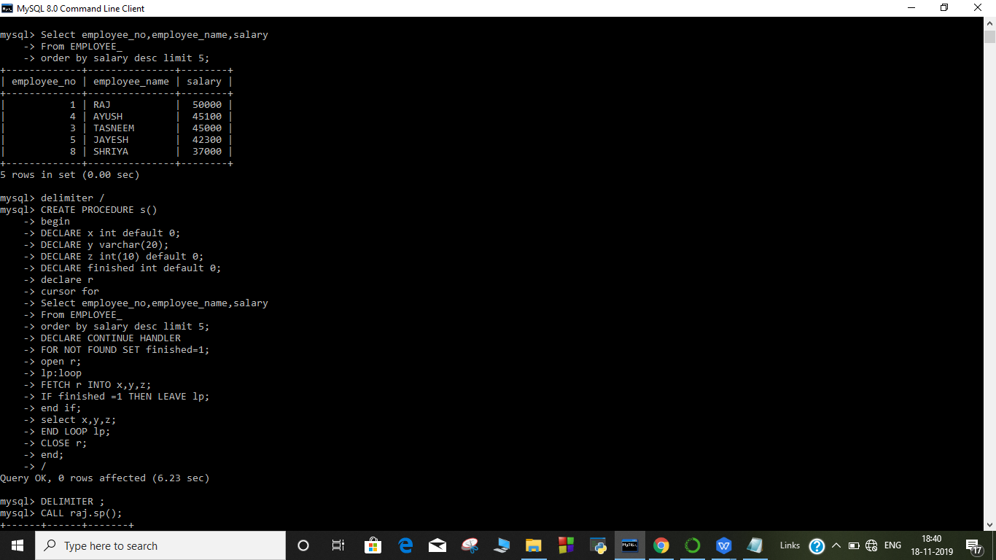

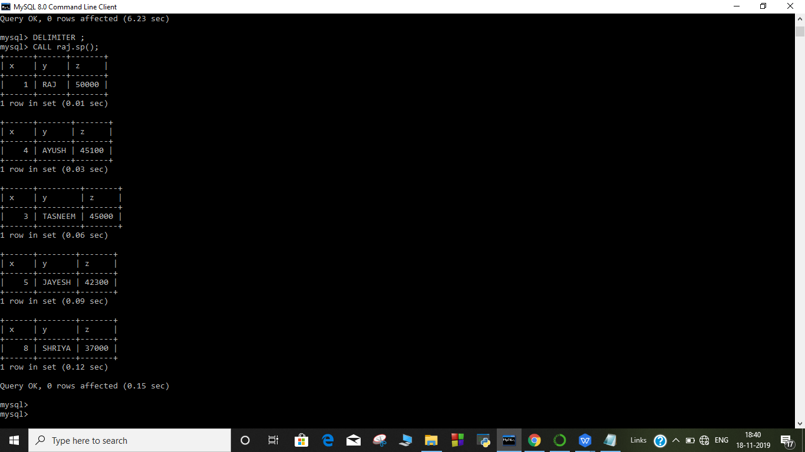

**OUTPUT:-**

**Table EMPLOYEE_**

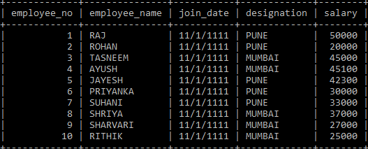

**IMPLICIT CURSOR**

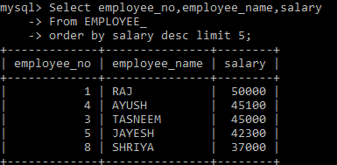

**EXPLICIT CURSOR:**

